草酸锂质量检验报告单
QUALITY TEST REPORT FOR Li2C2O4
产品名称：  Product name | 草酸锂 |  | 批号：  Lot No. |  | 20240106
生产日期：  Production date | 2024-01-06 |  | 产品规格：  Product Specifications |  | 99.9%
检测日期：  Inspection date | 2024-01-07 |  | CAS号：  CAS NO. |  | 533-91-3
检验结果Test Results
组成成分  Composition |  | 标准  Content Requirements(%) |  | 实测值（%）
Li2C2O4 |  | ≥99.9 |  | ＞99.9
Na |  | ≤0.001 |  | 0.0005
K |  | ≤0.001 |  | 0.0007
Fe |  | ≤0.001 |  | 0.0003
Ca |  | ≤0.001 |  | 0.0005
Mg |  | ≤0.001 |  | 0.0004
H₂O |  | ≤0.05 |  | 0.025
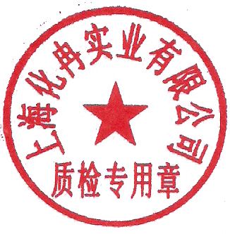  游离酸 |  | ≤0.03 |  | 0.0012
检验结果：合格 检验员：01
Test results: qualified Review staff:

